BitInvest Installation and Basic Setup Guide

Install Apache

Our next step is to install Apache. Type the following commands in the terminal:

sudo apt-get update

sudo apt-get install apache2

You will be prompted with a (Y/n). Type y and press Enter.

You can do a spot check right away to verify that everything went as planned by visiting your server's public IP address in your web browser.

http://your_server_IP_address

You will see the default Ubuntu 16.04 Apache web page, which is there for informational and testing purposes. It should look something like this:

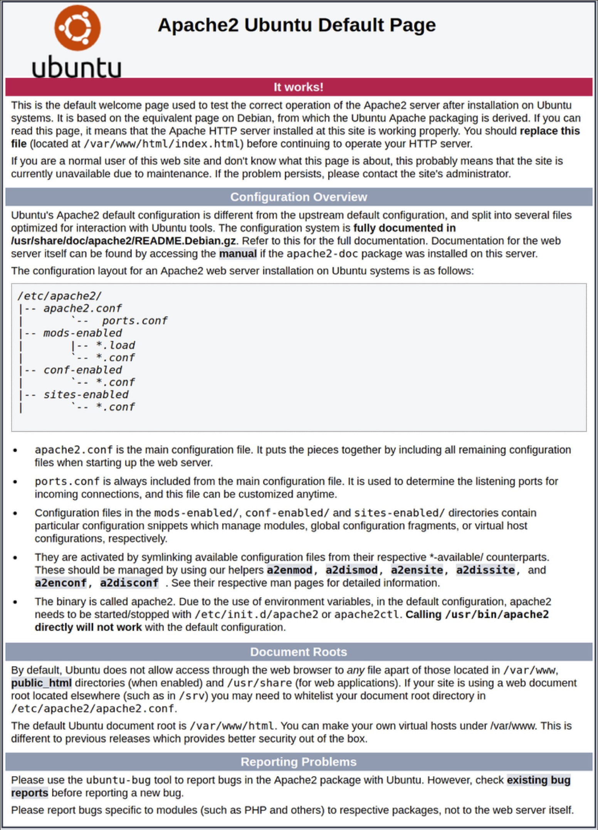You have now installed Apache web server successfully.

3. Install MySQL

Now that we have our web server up and running, it is time to install MySQL. MySQL is a database management system. Basically, it will organize and provide access to databases where our site can store information.

Type in the following commands into the *Terminal*:

sudo apt-get install mysql-server

You will be prompted with a (Y/n). Type y and press Enter.

You will be prompted to enter a password for MySql. Enter a secure password and press Enter. Save this password. You will need this to login to your database.

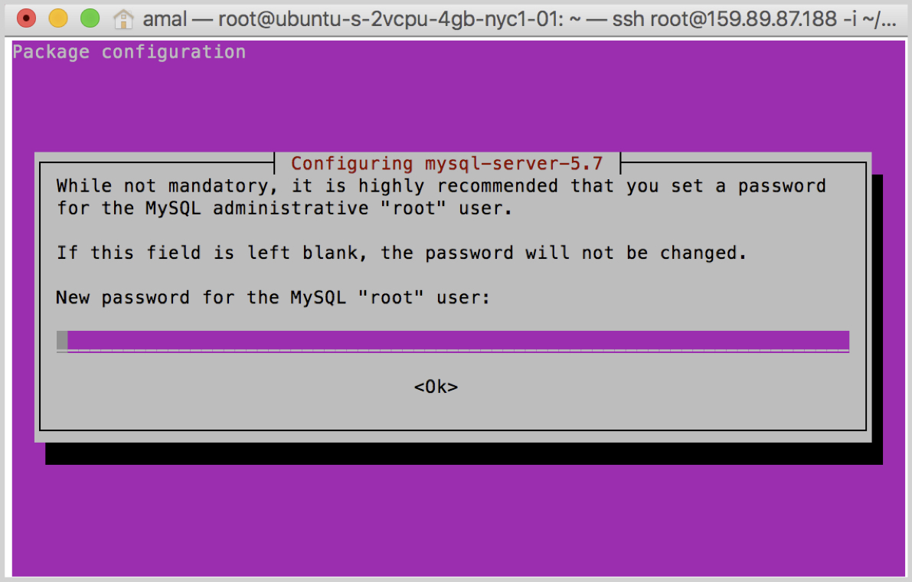You have now installed MySql database successfully.

4. Install PHP 7.0

PHP is the component of our setup that will process code to display dynamic content. It can run scripts, connect to our MySQL databases to get information, and hand the processed content over to our web server to display.

Step 1: Install PHP to server Type the following commands into the *terminal*:

sudo apt-get install php7.0 libapache2-mod-php php-mcryptphp-mysqlphp-gdphp-bcmath

You will be prompted with a (Y/n). Type y and press Enter.

This should install PHP without any problems.

Change the location of index.php

To do this, type this command to open the dir.conf file in a text editor with root privileges:

sudo nano /etc/apache2/mods-enabled/dir.conf

Inside of the file will look like this:

DirectoryIndex index.html index.cgi index.pl index.php index.xhtml index.htm

We want to move the index.php file above to the first position after the DirectoryIndex, like this:

DirectoryIndex index.php index.html index.cgi index.pl index.xhtml index.htm

When you are finished, Press Control + O to save.

And press Enter.

Then press Control + X to exit.

You have now installed PHP successfully.

5. Enabling pretty URLs

Next, we need to enable pretty URLs by the following commands:

sudo a2enmod rewrite

nano /etc/apache2/apache2.conf

Press the down arrow until you reach  {Directory /var/www}

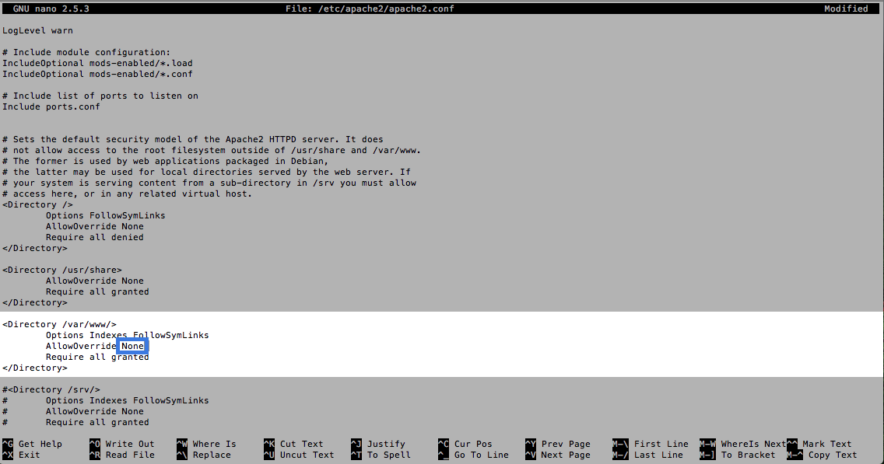

Change "AllowOverride" from "None" to “All"

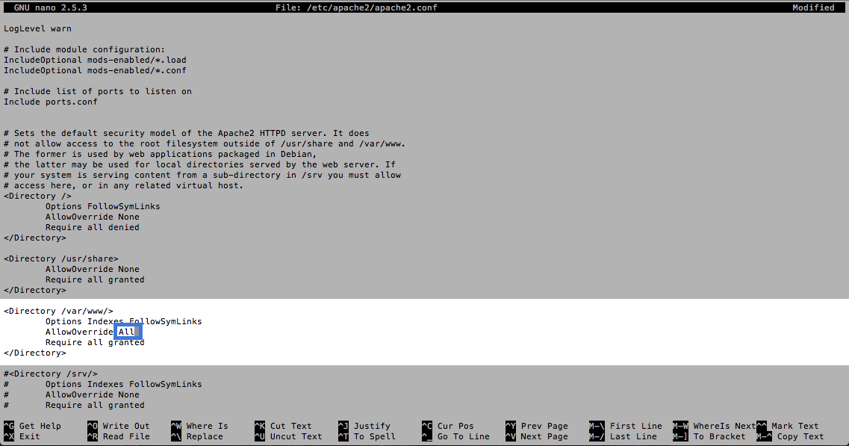

Press Control + O to save. And press Enter. Then press Control + X to exit.

Restart the apache server by entering the following command in your terminal.

sudo service apache2 restart

6. Install CLI and CURL

To do this, type the following command into your *Terminal*:

sudo apt-get install php-cli php-curl curl

You will be prompted with a (Y/n). Type y and press Enter.

You have now installed CLI and CURL successfully.

7. Install Composer

Type the following command into your Terminal to install Composer globally:

curl -sS https://getcomposer.org/installer | sudophp -- --install-dir=/usr/local/bin —filename=composer

You have now installed Composer successfully.

8. Uploading source code to server

This section shows us how to upload the source code for the exchange to the server we've setup. We will be using FileZilla to upload the code with FTP as it is the easiest way for managing file transfers.

Download [FileZilla](https://filezilla-project.org/) and install it on your system.

Open FileZilla and go to *FileZilla>Settings*.

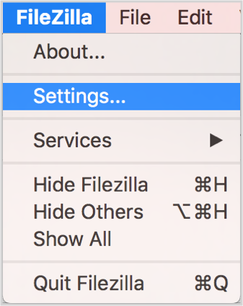

Go to SFTP tab.

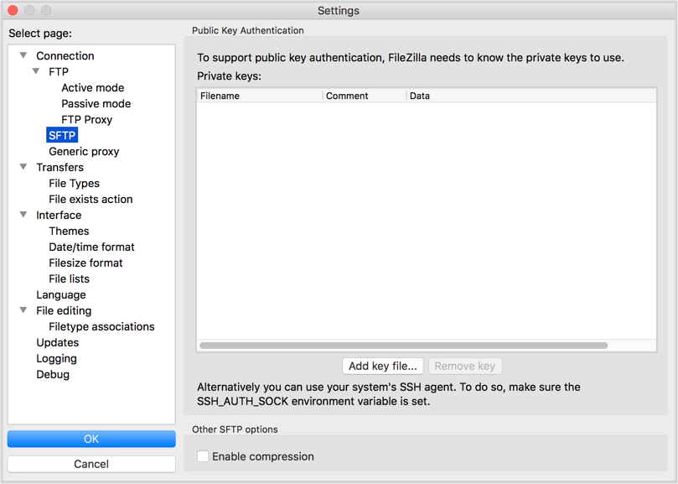

Press Add key file and select your SSH private key.

You will be prompted to enter your SSH key password. Once the key is added, press OK.

Now, enter*sftp://ip_address* of the droplet you want to connect in the Host field and give Username as *root*. Press Quickconnect to establish connection.



The left panel is your local directory and the right panel is the directory in your server. Now drag the **bitinvest.zip** you have downloaded and drop it to /var/www/html/ folder.

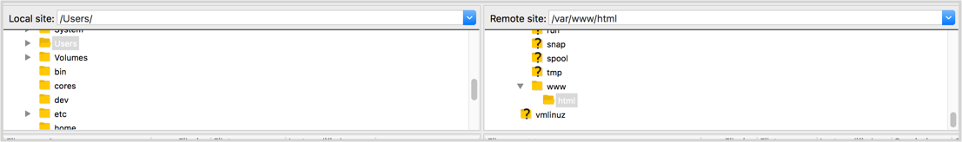

You have now successfully uploaded the code to the server.

9. Setting up Database

Install PHP My Admin-

sudo apt-get install phpmyadmin apache2-utils

Give the username and password for which you have given for mysql

sudo echo 'Include /etc/phpmyadmin/apache.conf' >> /etc/apache2/apache2.conf

Goto[www.yourdomain.com/phpmyadmin](http://www.yourdomain.com/phpmyadmin)

Login with the username and password

Create a database with name – bitlend

Goto import section and Import the bitlend.sql file which is available in the package.

10. Database Configuration

Goto .env file using the following command:

cd /var/www/html/

And configure the database name, username, password which you have given in step 3.

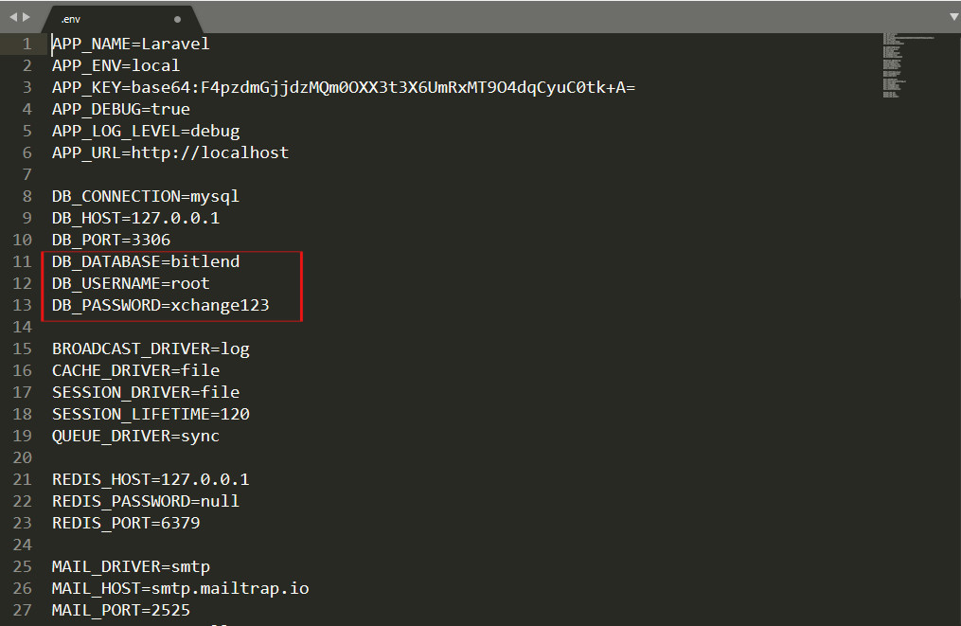

11. Check if index page and admin panel is working

[www.yourdomain.com](http://www.yourdomain.com)

www.yourdomainname.com/admin

Default Credentials ->

Username - [admin](mailto:admin@coincap.com)

Pass – admin